Leps 2.0 step by step-by-step user guide

Nonlinear shear strength envelopes for rockfill

The main shear strength equation (generalized, anchor-angle form):

$$τ=\tan{ϕ_{1}^{'}∙{\left(10p_{a}\right)}^{1-m}σ_{n}^{m}}$$

This is the recommended working form because it uses a physically meaningful “anchor” friction angle $ϕ_{1}^{'}$ (the secant friction angle at $σ_{n}=10 p_{a}≈1\text{ MPa}$) and a curvature $m$ that governs nonlinearity.

Key parameters (in the order they appear in the generalized equation):
- $τ$: Shear strength.
- $ϕ_{1}^{'}$: Secant friction angle at $σ_{n}=10 p_{a}$(≈1 MPa), degrees.
  - Controls the envelope inclination near the anchor stress; higher $φ_{1}^{'}$ stronger rockfill.
- $p_{a}$: Atmospheric pressure constant to keep things unit consistent.
  - $p_{a}=0.1013 MPa= 101.3 kPa = 14.70 psi = 2, 116 psf$.
- $m$: Curvature coefficient, dimensionless.
  - Bounded by $0.5≤m≤1.0$.
  - $m=1.0$→ linear Mohr–Coulomb.
  - $m↓0.5$→ more curvature (stronger drop of friction with stress).
  - Typical rockfill: $m≈0.9$ if you don’t have data to fit.
- $σ_{n}$: Effective normal stress on the failure plane

- Step 0: Verify that the material meets the criteria for rockfill.

Use this model only when gradation reflects rockfill behavior:
- %Gravel > 40% and %Fines < 25%.
- Median particle size D₅₀ > 2 mm.

These limits are based on accurate assessment and observed mixing behavior. Outside this range (excessively sandy or fine), rockfill envelopes may over- or under-predict. Refer to the ternary and particle-size plots for the defined application range.

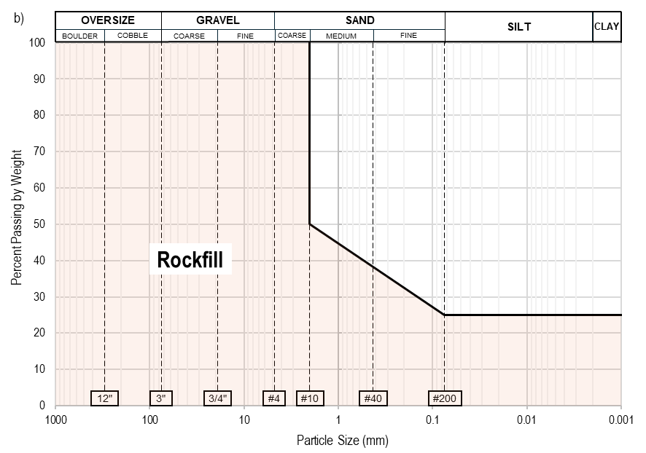

- Step 1 - Confirm project inputs (testing data not mandatory)

Ensure the project includes or can estimate the following:
- Rockfill quality: Classified as Good, Moderate, or Low based on lithology and origin (e.g., crushed basalt vs. fluvial gravel.
- Density: Preferably expressed as void ratio $e$; otherwise, assign a compaction/densification class (Dense, Medium, or Loose).
- Representative normal stress ($σ_{n}$): Estimated on the potential failure plane (MPa).
  - Select a mid-range $σ_{n}$ representative of the governing stress conditions (e.g., 0.3-1.0 MPa for near surface, > 1 MPa at depth).
  - Linearize the nonlinear shear-strength envelope at this stress level.

Rockfill strength exhibits mild nonlinearity; the linear friction angle should correspond to the stress range relevant to the design. The database indicates that linear fits yield comparable accuracy to the power-law model when the stress range is properly constrained.

- Step 2 - Estimate $ϕ_{1}^{'}$ from rockfill quality and compaction - no field-tested void ratio is available

If no field-tested void ratio is available, use the 3×3 matrix (rockfill quality × compaction class).

Rockfill Quality | Compaction
Rockfill Quality | Dense | Medium | Loose
Rockfill Quality | e = 0.30 | e = 0.45 | e = 0.60
Good | 47° | 44° | 41°
Moderate | 44° | 41° | 38°
Low | 41° | 38° | 35°

From the paper’s simplified model (Table of Envelopes), obtain $ϕ_{1}^{'}$ directly. The five reference envelopes (47°, 44°, 41°, 38°, 35°) represent over 900 tests and extend the framework of Leps (1971). They are recommended for preliminary or conceptual evaluations and not advised for feasibility or operational design stages.

- Step 3 - Estimate the shear envelope when $e$ is available and no lab tests.

From the database, typical rockfill exhibits $m≈0.9$ when no data is available for fitting. Accordingly, the shear response is expressed as:
$$τ=\tan{ϕ_{1}^{'}∙{\left(10p_{a}\right)}^{0.1}σ_{n}^{0.9}}$$

Then, use the paper’s linear relation:

$$ϕ_{1}^{'}≈ϕ_{e=0}^{'}-{20}^{∘}∙e →ϕ_{e=0}^{'}\left\{\begin{matrix}{53}^{∘} Good \\ {50}^{∘}Moderate \\ {47}^{∘} Low\end{matrix}\right.$$

Here, $ϕ_{1}^{'}$represents the secant friction angle at 1 MPa (anchor stress).

- Step 4 - Estimate the shear envelope when $e$ and lab tests are available

When site-specific data are available, calibrate the material constants as follows:

- Fit $m$ and $ϕ_{1}^{'}$- Plot shear stress ($τ$) versus normal stress ($σ_{n}$) and perform regression using:

$$τ=tan⁡(ϕ_{1}^{'}) (10p_{a})^{ 1-m} σ_{n}^{ m}$$
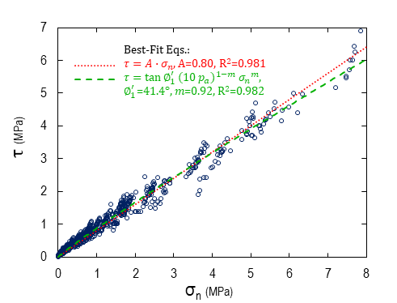
- Fit $ω$ and $ϕ_{e=0}^{'}$- In secant friction space, plot $ϕ_{1}^{'}$ versus $e$, then regress to obtain:

$$ϕ_{1}^{'}≈ϕ_{e=0}^{'}-ω\text{∙}e$$
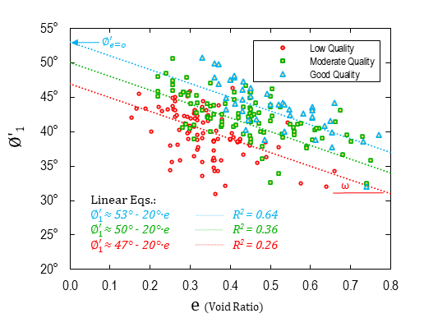
Report the calibrated constants $\{m, ϕ_{e=0}^{'}, ω\}$for each material to define the site-specific shear envelope.

- Step 5 - Estimate the shear envelope in the presence of weathering or leaching scenarios.

The effects of weathering were considered by applying a simple reduction of the secant friction angle by $ϕ_{reduction}^{'} = 7°$, yielding to:

$$τ_{weathered}=tan⁡(ϕ_{e=0}^{'}-ω\text{∙}e-ϕ_{reduction}^{'}) (10p_{a})^{ 1-m} σ_{n}^{ m}$$

- Step 6 - Estimate the shear envelope in the presence of densification or compaction.

In projects involving compaction or densification, where the densification profile can be accurately defined, such as in embankments, rockfills, or comparable engineered fills, the influence of densification may be incorporated into the Leps 2.0 framework through the void ratio, as outlined below:

$$τ_{densified}=tan⁡(ϕ_{e=0}^{'}-ω\text{∙}e_{f}) (10p_{a})^{ 1-m} σ_{n}^{ m}$$

$$e_{f}=0.65∙{\left(\frac{σ_{n}}{p_{a}}-\frac{0.18}{e_{i}^{4}}\right)}^{-0.25}$$

Assumption that the consolidation stress is equivalent to the normal stress on the failure plane
